To all tsiMORAY members

14 October 2019

Dear Member

tsiMORAY is currently looking for candidates to join its Board of Directors and we’d be grateful if you could circulate this opportunity through your networks.

The Board of tsiMORAY aims to provide sound strategic governance for a vibrant and dynamic organisation.

The current Board of eight directors is made up of people with a broad range of skills and knowledge, and with experience spanning the public, private and third sectors. Directors’ duties include monitoring the implementation of work plans, overseeing the management of finances and working with the Leadership Team and staff to identify priorities for shaping the future direction of tsiMORAY.

Full details of roles and responsibilities are provided in the information pack available on our website at www.tsimoray.org.uk, by email from info@tsimoray.org.uk or in printed form from tsiMORAY, 30/32 High Street, Elgin, IV30 1BU.

If you would like to be considered as a candidate for Director, we would invite you to complete the nomination form within the pack (appendix 2) and return to tsiMORAY by no later than 9am on Monday 28 October 2019.

If it can be arranged before the AGM, I would like to arrange to meet with prospective board members to have an informal chat about our organisation and to answer any queries you may have about the roles and responsibilities of directors. My email address is: don.vass@btinternet.com
In the event of there being more suitable candidates than vacancies, an election will be held at the next AGM taking place on Monday 4 November 2019. The information given on the nomination forms will be used to produce a ballot paper to enable members to make an informed choice.

Once appointed, Directors will be invited to participate in an induction and training programme. This will introduce Directors to the work of an Interface, other Board members, the organisation's staff and its activities through a variety of sessions which will help to further their knowledge and support the development of the new Board as an effective team.

Kind regards,
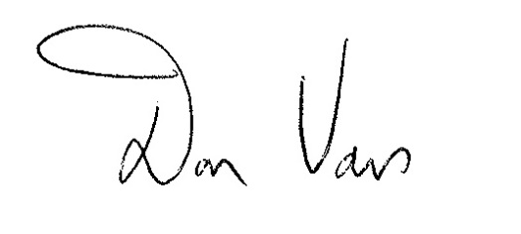

Don Vass
Chairman

tsiMORAY
30/ 32 High Street
Elgin, Moray
IV30 1BU
T: 01343 541713
E: info@tsimoray.org.uk
W: www.tsimoray.org.uk

