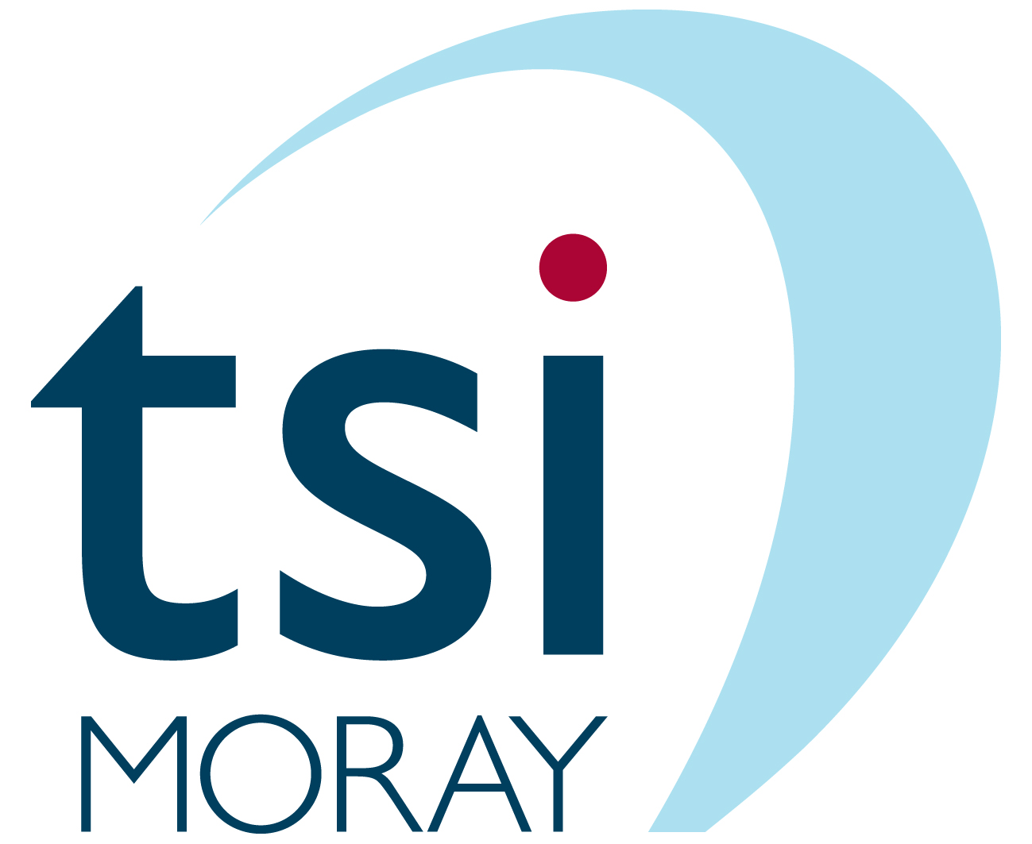

Becoming a Director of tsiMORAY,
the Third Sector Interface for Moray

Information
&
Application Pack

2021

Our Mission
tsiMORAY brings together and supports our third sector, enabling its full participation in the sustainable development of Moray.
Our Vision
A vibrant third sector in a resilient and sustainable Moray.

tsiMORAY – the Third Sector Interface for Moray

tsiMORAY is a dynamic local charity set up to support and promote volunteering, community groups, voluntary organisations and social enterprises. tsiMORAY also supports and promotes communication and collaboration between all of these organisations – often referred to as “third sector”, to differentiate them from the public and private sectors – and between them and public sector organisations, such as the Moray Council, the NHS, Police Scotland and more.

tsiMORAY is a company limited by guarantee with charitable status, currently governed by a Board of eight volunteer directors and employing 14 members of staff, providing third sector organisations with a one-stop service.

tsiMORAY is supported by Scottish Government through an annual grant of £201,600, which underpins our capacity to develop, promote, secure support for, manage, monitor and evaluate a wide range of projects to provide a variety of services to volunteers, third sector organisations and partners. This helps to deliver Scottish Government’s over-arching strategic aims for its third sector investment:
- effective governance and leadership
- deepening collaborative approaches across the sector to maximise impact
- helping to deliver greater fairness and equality.

tsiMORAY is also supported by our local partners, including Highlands & Islands Enterprise and The Moray Council.

The activities to be carried out by tsiMORAY to deliver our key outcomes are set out in our tsiMORAY Outcomes Framework, informed by input from our stakeholders and agreed with the Scottish Government’s third sector unit.

tsiMORAY is recognised as the Third Sector Interface for Moray; it represents the third sector on the Moray Community Planning Board as well as facilitating third sector engagement in other strategic partnerships and working groups. Its role includes specific responsibilities to provide an overview of relevant third sector activities as well as facilitating two-way communication with, and raising awareness of, relevant third sector organisations. tsiMORAY also plays a key role in facilitating and supporting the development of third sector and wider community involvement in the design and delivery of public services. tsiMORAY is the only third sector organisation in Scotland that delivered our area’s LEADER, a European programme supporting community-led local development. We continue to work closely with the Local Action Group made up of community, business and public sector members through a transitionary period.

tsiMORAY’s Outcome Framework supports the priorities of the Moray Community Planning Partnership set out in Moray 2027, which is the Partnership’s Local Outcomes Improvement Plan (LOIP).
Contents

- Introduction and Background

- Governance in tsiMORAY

- The Board of Directors – its Role and Responsibilities

- Structures for Governance

- Skills and Expertise

- Diversity

- Appointments Procedures

Appendix 1 Role Profile and Person Specification

Appendix 2 Nomination Form
1. Introduction and Background
The contribution that the third sector makes to civic society is recognised across the social policy spectrum, both nationally and locally. There is a considerable body of evidence attesting the value of the Sector and its contribution to the economy and to the strength of our communities in Scotland.
The background to the establishment of an interface between the third sector and Community Planning Partners reflects the Scottish Government’s aspirations that those who plan and deliver public services - Community Planning partners (such as the local authority, the NHS, police, colleges, Fire Service and the third sector) should work well together for the benefit of communities.
The Scottish Government asked that each Community Planning Partnership area (32 in Scotland) develop new interface arrangements by 31st March 2010 and that these be formalised, fully in place and functioning no later than April 1st 2011.
In Moray, it was agreed that the most effective way of meeting the challenge of the interface agenda, was to create a single organisation that would undertake the activities of three organisations - Volunteer Centre Moray, Voluntary Action Moray and Moray Social Enterprise Network. A new company, Third Sector Interface Moray (tsiMORAY) was formed and became operational in April 2012. Following a period of transition, a chief officer was appointed and took up post in February 2013 to provide leadership and to work with tsiMORAY's Board to ensure the effective delivery of the Company’s objectives.

2. Governance in tsiMORAY
Governance is the process by which a governing body makes sure that an organisation is effectively and properly run and meets its legal obligations. It is important to distinguish between governance matters and other management, operational or day-to-day management matters. Governance matters are the legal responsibility of the Board working together and taking responsibility for their decisions.
Other organisational matters may or may not be carried out by the Directors, paid staff, or volunteers, depending on the organisation’s size. tsiMORAY’s governance is the responsibility of the Board while the development and implementation of plans is the responsibility of the Leadership Team and staff. It is vital, therefore, that the right systems and procedures are in place to ensure good governance. The Board must then establish the systems and procedures which ensure that the activities of the Leadership Team can be supported, monitored and evaluated, in order to achieve the organisation’s objectives.

3. The Board – its Role and Responsibilities
The following statements provide a summary of the role and responsibilities of tsiMORAY's Board of Directors:
- To determine the organisation’s mission and vision – it is the responsibility of the Board to review and develop tsiMORAY’s mission and vision. Every policy decision the Board makes is designed to help the organisation realise the aims laid out in its Mission Statement.
- To engage in strategic planning – it is the responsibility of the Board to make strategic policy, and work with the Leadership Team and staff to develop long-term strategic plans. Meeting agendas can then be tied to key points in the strategic plan in order that the Board can deal with key issues.
- To formulate essential policies – the Board creates policies to govern organisational activity, providing guidance for staff, setting up systems for reporting and monitoring, and establishing an ethical framework for all those who work for or on behalf of the organisation. It also creates policy governing the behaviour of Directors and all aspects of Board business.
- To approve and monitor the organisation’s programmes and services – The Board sees to it that all the organisation’s programmes and services obey Company Law requirements and effectively serve the organisation’s mission. The Board’s vision for the organisation determines what direction these programmes will take.
- To ensure adequate financial resources – the Board ensures that the organisation has the resources to carry out its activities. Their work in this area may involve creating policies governing financial reserves and fundraising practice.
- To provide effective fiscal oversight and ensure sound risk management – the Board approves the annual financial statement and budget, monitors spending, creates policies to manage and protect organisational assets and property and sees to it that finances are handled according to the letter of the law in the best interests of the organisation. It also protects the organisation against liability by providing adequate insurance and creating policy designed to minimise the amount of risk for the organisation.
- To be responsible for the support and performance review of the Leadership Team and staff – it is the responsibility of the Board to create policy and procedures which enable the organisation to determine the remuneration of the Leadership Team and staff and an annual review of their performance. The Board is also responsible for ensuring the proper development of and support for the Leadership Team and staff throughout the year, through agreed procedures.
- To understand and respect the relationship between Board and staff – The Board recognises areas of staff responsibility and avoids involving itself in matters that are properly the domain of staff. At the same time, it creates policy to guide staff activities and safeguard the interests of the organisation.
- To enhance the organisation’s public image – through their own behaviour, their governance oversight and their activities on behalf of the organisation, members of the Board have a responsibility to enhance and protect the reputation of tsiMORAY.
- To carry out Board business efficiently – The Board keeps its own house in order by conducting productive meetings where key organisational issues are dealt with in an efficient way. If necessary, it creates Sub-Committees and provides them with adequate resources and personnel. It engages in regular performance appraisals, periodic self-assessment and development activities to strengthen its effectiveness.

4. Structures for Governance
The Board of Directors will comprise a maximum of 12 members, a majority of whom should be nominated by members i.e. representative of voluntary or community organisations or social enterprises that are registered members of tsiMORAY.
The Board may determine the need for thematic Sub-Committees to be formed by a subset of Directors to consider items such as, for example, Finance or Human Resources. A sub-group would meet between Board Meetings, in order to deal with issues which require on-going attention, and to take certain decisions which fall within its remit. In addition, the Board may wish to recruit individual members with specific expertise, on a short-term basis, in order to address specific issues.
The Board may delegate decisions to Sub-Committees, but the Board is ultimately accountable for decisions taken.
The role and accountability of each Sub-Committee should be clear to all members of the Sub-Committee and Board.
Sub-Committees should be reviewed on a regular basis to ensure that they are fulfilling their role effectively.

5. Skills and Expertise
tsiMORAY’s Board of Directors will be the governing body of the organisation and ultimately responsible for everything the organisation does. It will be accountable in law to the courts. Directors must act in the best interests of the organisation’s beneficiaries, exercising the same duty of care that a prudent person of business would in looking after the affairs of someone for whom they had responsibility.
Directors must act together as a group rather than as individuals, setting aside their personal interests and giving their time to carry out their duties for no payment or gain other than in exceptional circumstances. A Director’s personal interests, the views of a certain section of membership or staff or any outside interests must be left behind before s/he sits down at the meeting table.
It is essential that tsiMORAY’s Board of Directors is made up of a range of individuals who bring to the organisation the right mix of skills, experiences and qualities. These skills, experiences, and qualities are key ingredients in building an effective board of Directors.
Less “tangible” skills are often among the most important yet least recognised. People become Directors for many different reasons and can bring many valuable experiences with them. Building an effective board involves a number of factors and ensuring that the organisation is effective and reflects the community it serves is a step towards achieving this. As well as specific skills, all Directors should have certain qualities which make them suitable for holding the position of Company Director. In 1995, the Nolan Committee identified seven principles of public life that should guide public figures. These principles are:
- Selflessness
- Integrity
- Objectivity
- Accountability
- Openness
- Honesty
- Leadership
These seven principles will be contained in tsiMORAY’s Code of Conduct helping to ensure Directors safeguard the integrity of the organisation and maintain public confidence in the third sector. Directors must also have some qualities that will enable their board to work together and reach decisions in a consensual way:
- A sense of leadership
- A sense of duty
- An ability to exercise judgment
- An ability to be open minded when seeking solutions
- An ability to balance tact with candour
- A preparedness to work collectively
Each year, tsiMORAY will carry out a skills audit of its Board in order to take advantage of existing strengths and to identify gaps which may have emerged as a result of the resignation of a Director, or a change in the organisation’s strategic direction.

6. Diversity
With increasing demands for public accountability and effectiveness, third sector organisations are looking closely at how they reflect and are responsive to the needs of the communities they work for. Organisations are becoming increasingly more inclusive by giving beneficiaries and stakeholders more of a say in decision-making. This is an important consideration for tsiMORAY’s Board of Directors, which seeks to include individuals from a variety of communities, as well as those with the required skills and expertise. The diverse skills, experiences and backgrounds of Directors will contribute overall to the organisation’s effectiveness.
Diversity means difference, and people’s differences can be many and varied, including: race, culture, gender, sexual orientation, politics, age, religion and faith, disability, socio-economic differences and values.
Everyone is different, and the number of differences that exist in one person can include more than one of those listed above. Awareness of diversity and taking action on diversity is not just about individual board members representing specific groups. It is about recognising that to be effective, an organisation needs to be diverse.
The challenge for tsiMORAY’s Board will be to be responsive to needs of volunteers, third sector organisations and other stakeholders, accountable to the communities and people being served and ultimately, effective in doing its job. This rarely happens by accident, and good intentions are just the start. Building an effective Board requires careful thought and planning, and above all requires a commitment and willingness to change: to look hard at the Board on a regular basis, to make changes, question old assumptions, and bring in new ideas.
It is important to recognise that diversity is not just about representation. There can be a danger of tokenism, when individuals are perceived as speaking for a particular group and not having any other contribution to make. What is important is that each part of an individual’s skills and perspectives adds value to the work of the Board.

7. Appointment Procedures
tsiMORAY relies on an active and interested membership as a foundation for its activities. Nominations for Directors are invited from its membership and approved at the AGM. The Constitution of tsiMORAY also allows membership of the Board to be open to representatives of organisations not registered as members and to individuals who can bring particular skills or experience to the Board.
In the event of there being more nominations than vacancies, an election will be held at the AGM. If a representative of your organisation wishes to contribute to the development of the third sector in Moray by becoming a Director, please complete the nomination form (Appendix 2). The information given will be used to produce a ballot paper to enable members to make an informed choice.
Once appointed, Directors will be invited to participate in an induction and training programme. This will introduce Directors to the work of an Interface, other Board members, the organisation's staff and its activities through a variety of sessions which will help to further their knowledge and develop a synergy between members.

Appendix 1

Role Profile
The duties of a Member of the Board of Directors of tsiMORAY are:
- To ensure that the organisation complies with the requirements of the law in relation to Companies, and in particular OSCR regulations;
- To ensure that the organisation pursues its objectives as defined in its Articles & Memorandum of Association;
- To ensure that the organisation applies its resources exclusively in pursuance of its objectives;
- To contribute actively to the Board of Directors’ role in giving firm strategic direction to the organisation, setting overall policy, defining goals and setting targets and evaluating performance against agreed targets;
- To safeguard the good name and values of the organisation;
- To ensure the effective and efficient administration of the organisation;
- To ensure the financial stability of the organisation;
- To protect and manage the property of tsiMORAY and to ensure the proper investment of tsiMORAY funds;
In addition to the above statutory duties, each Director should use any specific skills, knowledge or experience they may have to help the Board of Directors reach sound decisions. This may involve scrutinising board papers, leading discussions, focusing on key issues, providing advice and guidance on new initiatives, or other matters in which the Director has special expertise.

Person Specification
- A commitment to the organisation
- A willingness to devote the necessary time and effort
- An ability to work effectively as a member of a team
- An acceptance of the legal duties, responsibilities and liabilities of trusteeship
- Strategic vision
- Good, independent judgment
- An ability to think creatively
- Act in accordance with the Nolan’s seven principles of public life: selflessness, integrity, objectivity, accountability, openness, honesty and leadership.
- A willingness to speak their mind

Additional Skills and Experience
There are a wide range of knowledge, skills and experience that would be helpful for the Board to carry out its role and responsibilities. Some examples are
- Financial Management
- Marketing/PR and Press
- Volunteering Development
- Social Enterprise Development
- Community Planning in Moray
- Charity Law and OSCR
- Leadership
- Managing Staff
- IT and Data Management
- Health and Safety & Risk Management
- Government Policy for Third Sector
- Employment Law
- Strategic and Business Planning
Please indicate any areas of interest or knowledge when completing the Nomination Form (Appendix 2)

Appendix 2

Member of the Board of Directors of tsiMORAY

Nomination Form
We welcome your application to join the Board of tsiMORAY. Please complete the following:

Name

Address

Telephone

Email

1. Please tell us why you would like to join the tsiMORAY Board.

2 Please provide a statement of no more than 70 words summarising why members should elect you as a Director of tsiMORAY. This information may be made available to members before the AGM to enable them to make an informed choice

Representative member nomination name:
Signed by nominee:

Nominating organisation:

Name of Organisation
Registered member of tsiMORAY | YES NO
Nominated by
Signed

Print name
A member of the Board or management committee of the nominating organisation must sign

Please return your completed nomination form to:

by email to: info@tsimoray.org.uk

to arrive no later than 12 noon on Wednesday 24 November 2021

