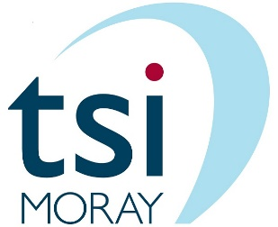
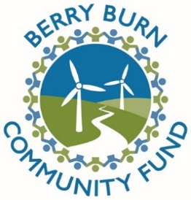

Berry Burn Community Fund
COVID-19 Emergency Fund Guidance for the Moray area

Background

- The Berry Burn Community Fund has made emergency funding available for the second time to support voluntary and community groups operating in the Fund area responding to the COVID-19 pandemic.

- Only applications from organisations and individuals operating or providing services to communities in the current community council boundaries of Forres (zone 3), Speyside (zone 6), Heldon (zone 5), Findhorn & Kinloss (zone 4), Finderne (zone 7) and Dyke Landward (zone 1) are eligible for consideration. See http://berryburncommunityfund.co.uk/about/ for detailed map.

- The focus of the funding is for those offering direct support to people and communities affected by the pandemic in the zones described above.

- tsiMORAY will administer applications to this fund, enabling the funder to allocate and deploy resources quickly to community and voluntary organisations in the Fund area where communities are disproportionately affected by COVID-19.

- Decisions will be made by a Berry Burn Community Fund panel.

Information for applicants

- This is short-term/emergency funding and we envisage most grants will be for a few hundred pounds, however, there is no maximum grant size (total funding pot = £5k). We reserve the option therefore to make a contribution to costs as opposed to giving the full amount requested where we feel this will make best use of the funds available.

- The grant funding scheme will provide a total of five thousand pounds to the Fund area starting in April 2020 through small grants.

- Groups eligible to apply are community and voluntary organisations at the frontline of providing services to people in the Fund area communities, with a focus where communities are disproportionately affected by COVID-19. Service examples include (but are not restricted to) preparing and delivering food, co-ordinating the delivery of essential supplies, providing befriending services, practical support for those with mental health challenges, etc.

- The £5,000 will be distributed as quickly as possible using a simple application and decision-making process.

- Grants are offered as unrestricted funds; they will be based on a specific request in terms of how much they need and what for.

- We will require feedback on how the funds have been used e.g. an update email/completion report with basic details of how the money was spent and the impact it had.

- Upon the receipt of a satisfactorily completed application form, applicants can expect to receive notification of the Berry Burn Community Fund panel decision from tsiMORAY as soon as possible, and normally within five working days.

- There is no fixed deadline for applications, however, funds are limited, so please apply quickly to increase your chance of receiving the funds you need.

- Application forms should be sent electronically in Microsoft Word format to: info@tsimoray.org.uk

- Your application should include answers to ALL questions on the application form. If any questions are left un-answered we will need to return it to you and this may delay a decision for your application.

- Wherever possible the grant will be paid by direct bank transfer.

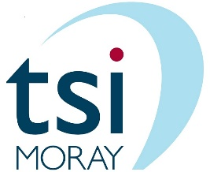

Application Form

1. Full name of your group (if applicable)

Group Name

2. Your address / address of your group (include a website address if applicable)

Address

Postcode

Website

Charity number (if applicable)

3. Contact name, email address and telephone number for the application

MAIN CONTACT DETAILS
Contact Name
Contact Email
Contact Telephone

RESERVE CONTACT DETAILS to be contacted if main contact is not available
Contact Name
Contact Email
Contact Telephone

4. Please provide a brief description of your organisation

5. Which zone or zones in the Berry Burn Fund area will benefit from your service/support?
(See Guidance above and www.berryburncommunityfund.co.uk)

6. Please set out how you provide / intend to provide services or support to the zone/s identified in question 5 in response to the COVID-19 pandemic (activities) and the difference these activities will make (outcomes)?

Activities:

Outcomes:

7. What is the total amount being requested under this grant scheme? Please include a breakdown of costs below, including estimates (please indicate) where necessary.

Breakdown of costs
Item required | Cost
Total amount being requested from this fund | £

8. Are you looking for other funding in addition to this grant in order to increase your response to COVID-19 in your community (this will not affect our decision regarding this application)?

Fund name | Amount sought | Status (please delete)
 | £ | Accepted/Declined/In Progress
 | £ | Accepted/Declined/In Progress
 | £ | Accepted/Declined/In Progress
 | £ | Accepted/Declined/In Progress
 | £ | Accepted/Declined/In Progress

9. Please provide appropriate and correct bank details for funds to be paid into should your application be successful.

Name of Bank Account
Account Number
Sort Code

10. Please check the boxes to confirm:
☐ You are an individual, community or voluntary group (formal or informal) providing or intending to provide services / support to people in the Fund area in response to the COVID-19 pandemic.
☐ If you are applying on behalf of a constituted group: your governing body or management committee know about this application and have agreed to you sending it to tsiMORAY
☐ You are willing to comply with the criteria of the grant as set out above.
☐ Your application does not campaign for specific religious or political beliefs.
☐ Your application does not oppose renewable energy and sustainability.
☐ You agree to tsiMORAY and Berry Burn Community Fund contacting you in relation to this grant funding.
☐If successful in this application, you will fully acknowledge the Berry Burn Community Fund in your publicity. You agree to - and will, if asked, participate in - any publicity organised by the Fund.
☐ You have read and understood tsiMORAY’s Privacy Notice and Berry Burn Community Fund Privacy Notice

11. Please sign and date this form.

Signature of main contact (If you are unable to insert a scanned signature, please type your name in full) | Date
Please email your completed application form to info@tsimoray.org.uk
This guidance document and application form was published on 16 February 2021.

